**SysOps Tools AWS (Amazon Web Services) Basics**

**Name: Lavish Sharma**

**Batch: 9**

Sprint - 1 (Assignment - 2)

**Task** - Create an S3 Bucket and deploy a static website on S3 Bucket.

1. Firstly, to create the S3 Bucket we need to log-in to our AWS Account and open **Management Console**.

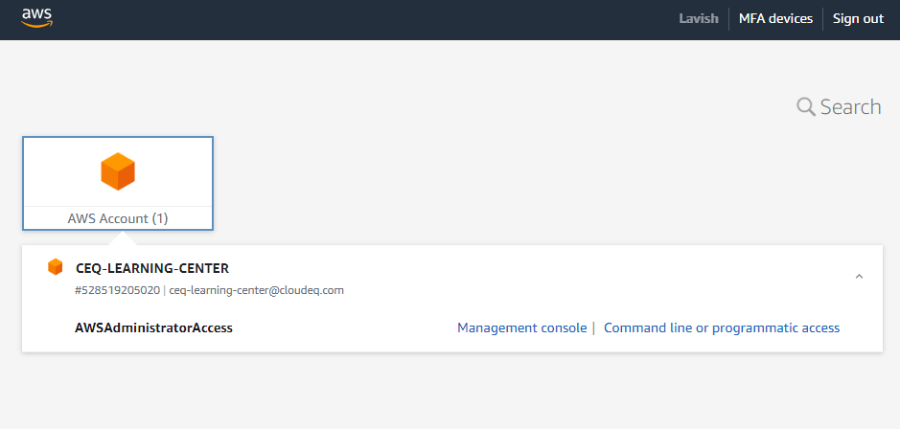

1. After opening Management Console, search for S3 and open **S3 Buckets**.

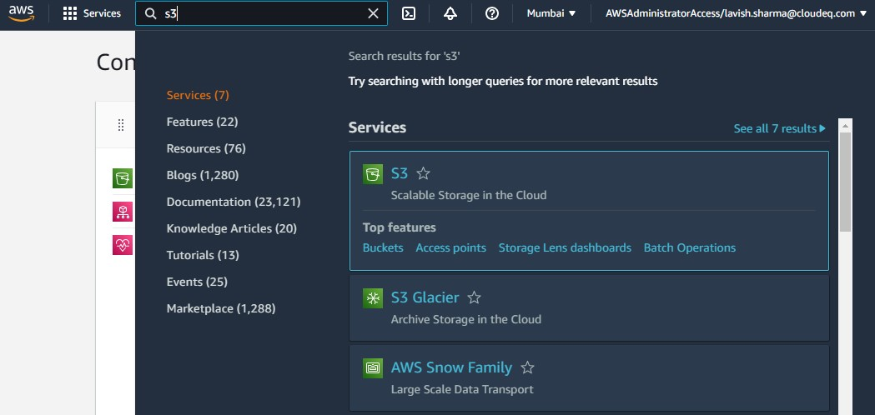

1. Amazon S3 Buckets section will open where we can see list of buckets created. Now to create a new bucket click on the **Create Bucket** button.

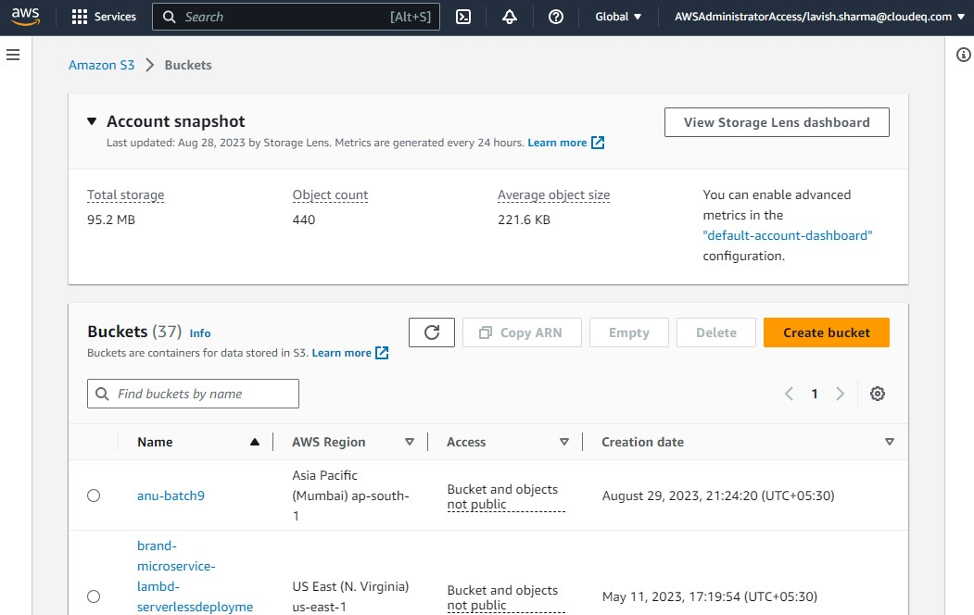

1. Now we need to provide Bucket name which should **globally unique** and select region.

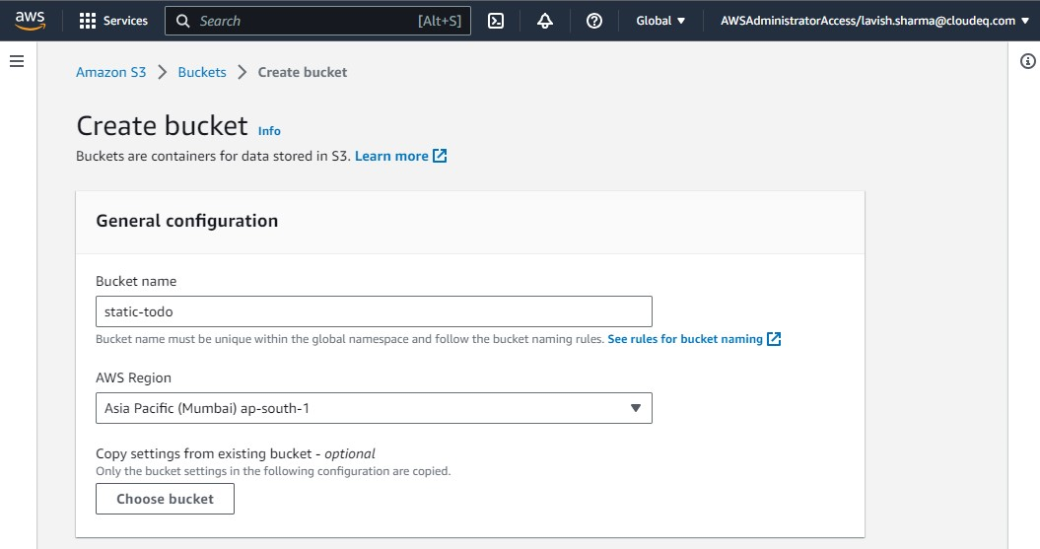

1. In this case, we are hosting a website which should be accessible globally for that ACL should be enabled and turn off Block all public access. So that everyone can access it.

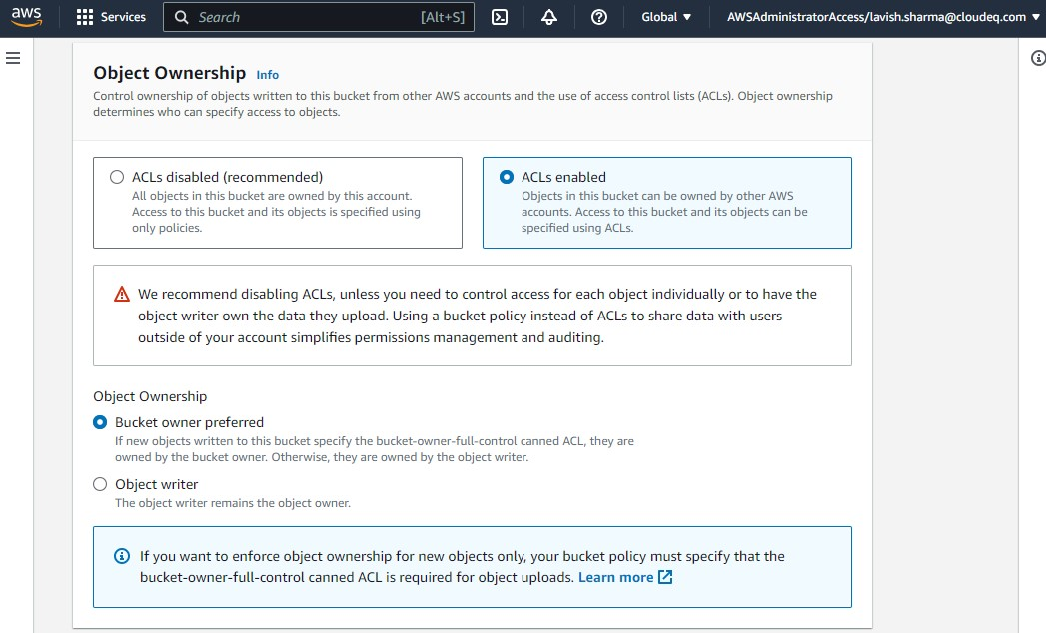

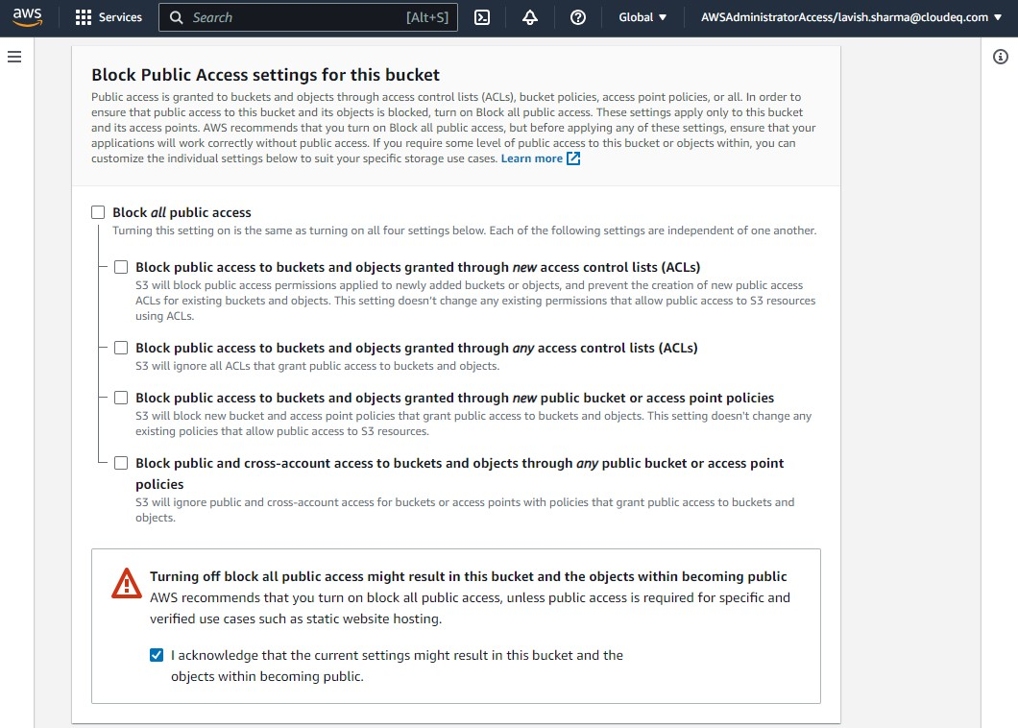

1. Providing tags to track storage costs and organize buckets.

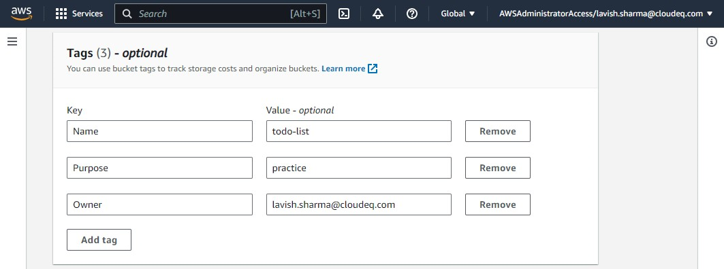

1. Finally, click the **Create Bucket** button and our new bucket is created. And now to upload our website on newly created bucket named **“static-todo”**, click on the name of out bucket.

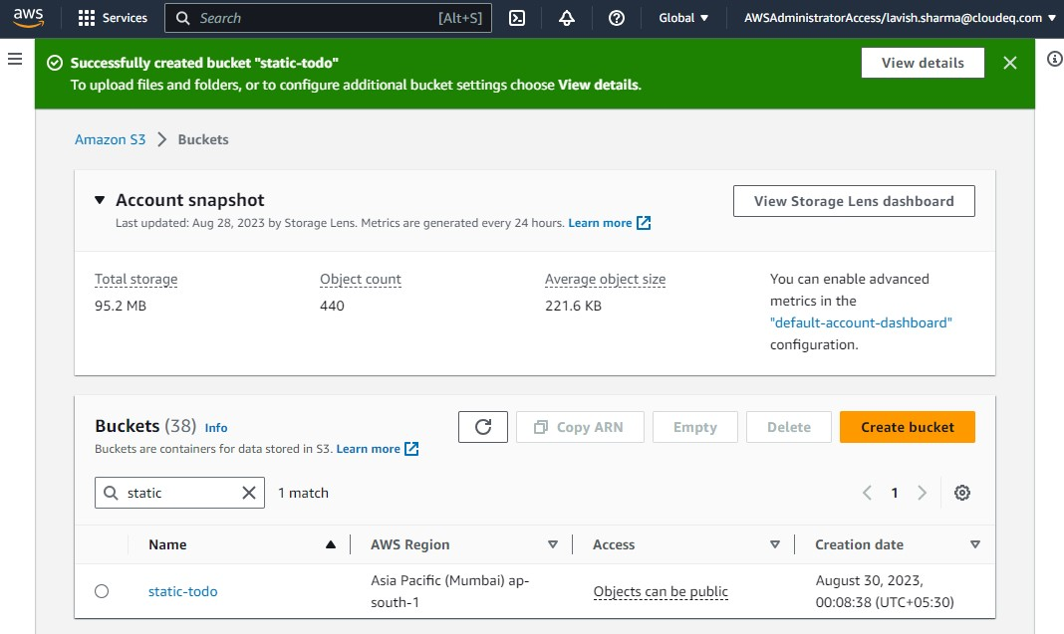

1. Now to upload website, click on **Upload** and select website that need to be uploaded for hosting.

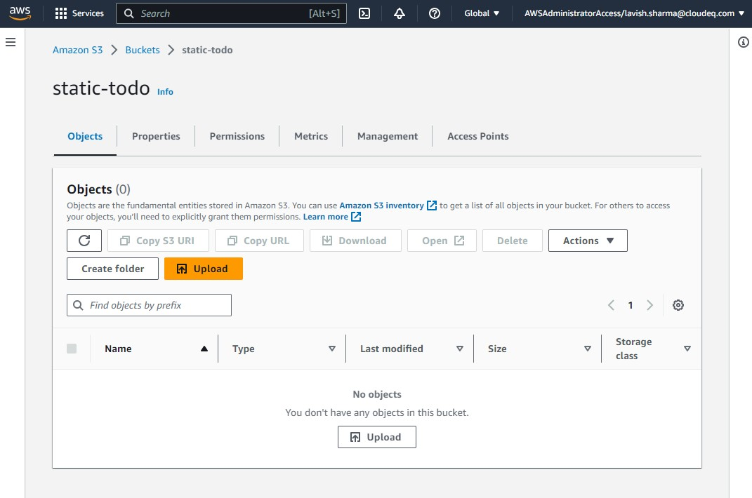

1. While uploading website, we need to change permission of ACL to **Grant public –read access.**

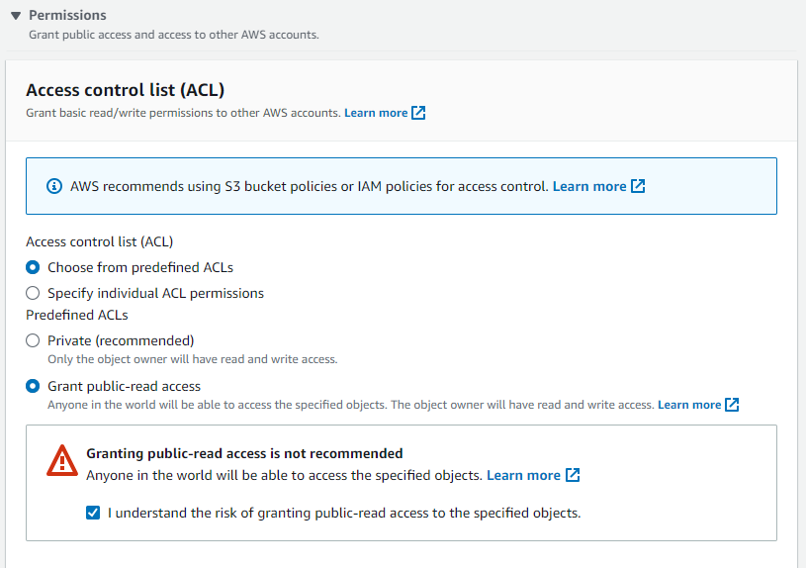

1. Click the **Upload** button and our website should be uploaded.

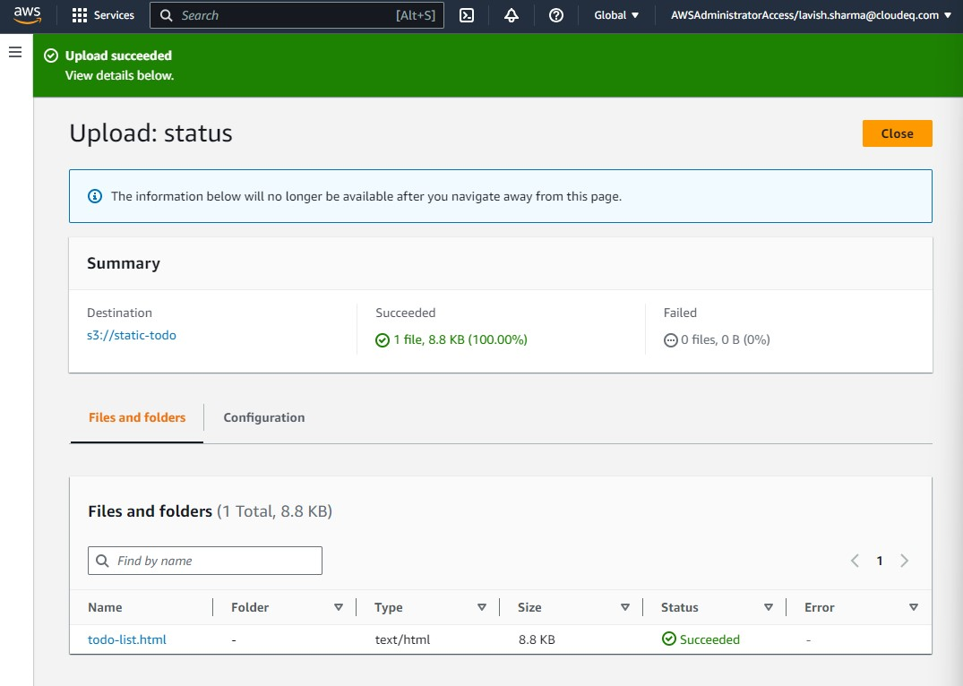

1. Now to open our website Copy its URL by clicking on the **Copy URL** button.

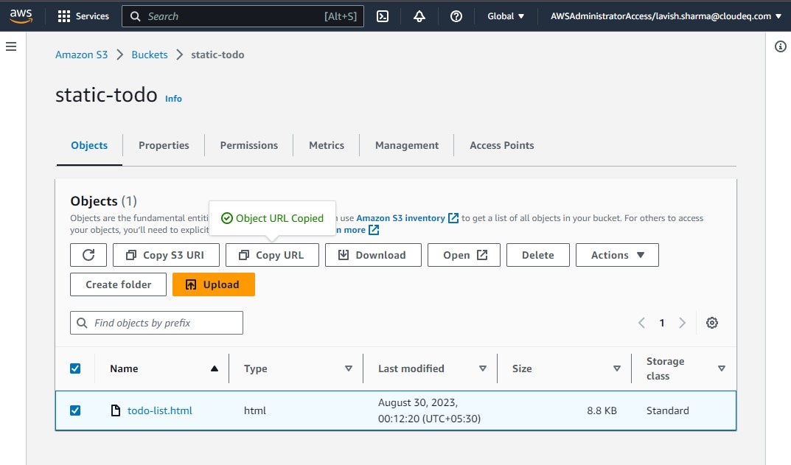

1. And paste copied URL in new tab.

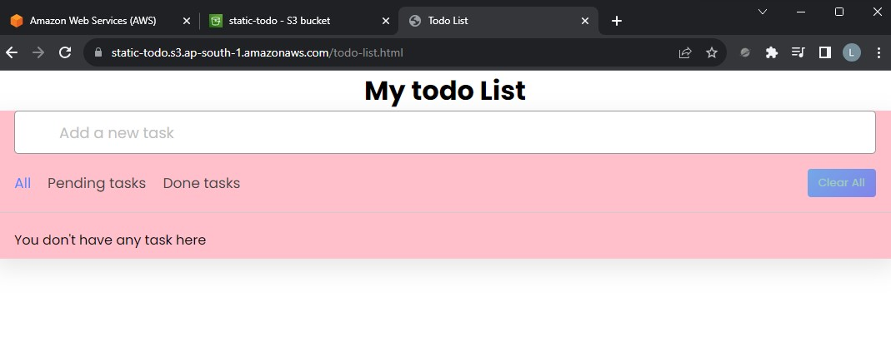

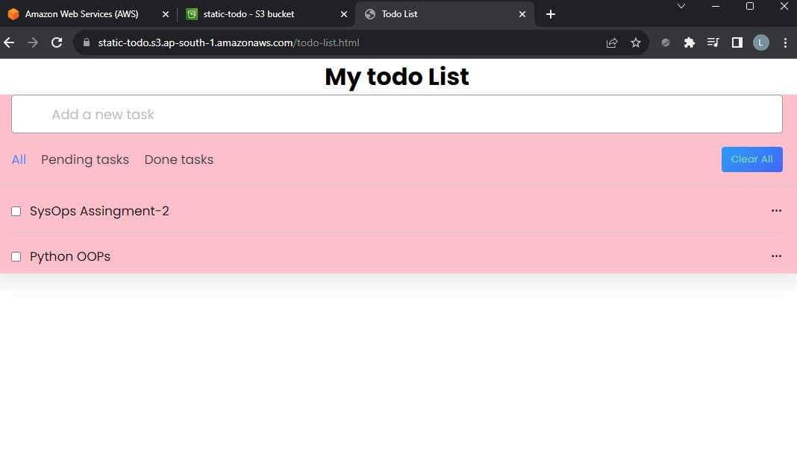

We successfully hosted our static website using S3 bucket.